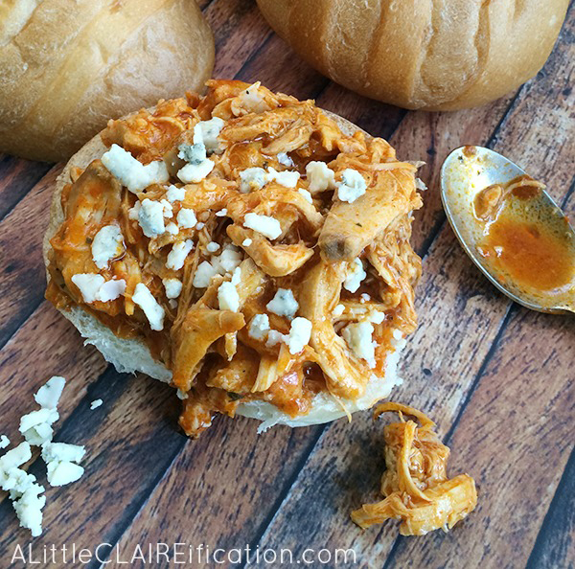

3 Ingredient Slow Cooker Buffalo Chicken
Ingredients
1 package (28 oz) boneless skinless chicken thighs
1 package (1 oz) ranch dressing and seasoning mix
1 bottle (12 oz) Buffalo wing sauce (such as Frank's)
Directions
Add the ranch dressing packet to a large bowl.
Toss each piece of chicken to coat and add to the slow cooker.
Add the bottle of Buffalo sauce and toss to coat the chicken.
Cook on LOW heat for 5 hours.
Remove the chicken to another large bowl and shred using two forks.
Return the chicken to the slow cooker and toss once more to coat with the sauce.
Keep warm and serve on sandwich rolls.
Top with crumbled blue cheese if desired.
Serves 4-5 people.

